CREATE TABLE Orders (
OrderID INT PRIMARY KEY,
CustomerID INT,
OrderDate VARCHAR(50),
);

INSERT INTO orders(OrderID, CustomerID, OrderDate)
VALUES
(10308, 2, '1996-09-18'),
(10309, 37, '1996-09-19'),
(10310, 77, '1996-09-20');
SELECT * FROM `orders` WHERE 1
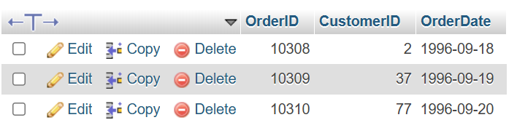

CREATE TABLE customers(
CustomerID INT PRIMARY KEY,
CustomerName VARCHAR(50),
ContactName VARCHAR(50),
Country VARCHAR(50));

INSERT INTO customers1(CustomerID, CustomerName, ContactName, Country)
VALUES
(1, 'Alfreds', 'Maria', 'Germany'),
(2, 'Ana', 'Ana', 'Mexico'),
(3, 'Antonio', 'Antonio', 'Mexico');

SELECT * FROM `customers1` WHERE 1

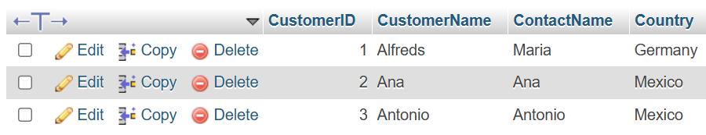

SELECT orders.OrderID, customers1.CustomerName, orders.OrderDate
FROM orders
INNER JOIN customers1 ON orders.CustomerID=customers1.CustomerID;

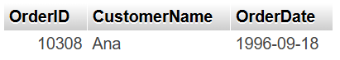

SELECT orders.OrderID,
customers1.CustomerName,
orders.OrderDate,
customers1.Country
FROM orders
LEFT JOIN customers1
ON orders.CustomerID = customers1.CustomerID;

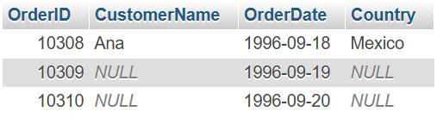

SELECT orders.OrderID,
customers1.CustomerName,
orders.OrderDate,
customers1.Country
FROM orders
RIGHT JOIN customers1
ON orders.CustomerID = customers1.CustomerID;

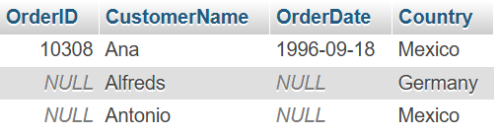

INSERT INTO orders(OrderID, CustomerID, OrderDate)
VALUES
(10311, 3, '1996-09-21');
SELECT * FROM `orders` WHERE 1

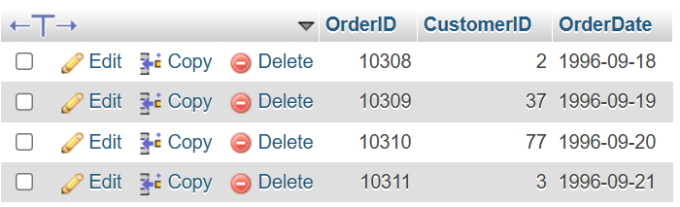

SELECT orders.OrderID,
customers1.CustomerName,
orders.OrderDate
FROM orders
INNER JOIN customers1
ON orders.CustomerID=customers1.CustomerID;
SELECT * FROM `customers1` WHERE Country = 'Mexico';

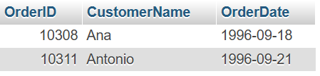

SELECT *
FROM Orders
JOIN Customers
ON Orders.CustomerID = Customers.CustomerID;

